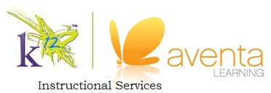
Study Guide
for Unit Exams in Chemistry A
Unit II: Chemistry All Around
The following provides information about the content of this exam. Of course, any topic covered in the unit may be represented on the exam. Please use this sheet as a guide as you study. As always, let me know if you have any questions!
Exam Format:
- 18 Multiple Choice (3 points each)
- 4 Essay (5 points each)
- 13 T/F (2 points each)
Material to Review:
- States of Matter
- Building Blocks of Matter
- Separation Techniques
- Reversible and Irreversible Reactions

Terms to Know:
(Make sure you can define and discuss each)
- Chemical and Physical Property
- Mixture
- Solution
- Solvent
- Solute
- Homogeneous and Heterogeneous Mixture
- Colloid
- Suspension
- Matter
- Element
- Molecule
- Compound
- Extensive and Intensive Property
- Chemical and Physical Change

